go.eIDAS launches #eIDAS4all campaign and eIDAS-Forum
[Lichtenfels, 2020/05/26] The non-profit go.eIDAS-Association has launched the international #eIDAS4all campaign and eIDAS-Forum to push forward the broad and fast adoption of electronic identification (eID) and trust services according to the eIDAS-Regulation. The open initiative invites all interested individuals and organisations to benefit from eIDAS within their individual applications and shape the trustworthy digitalisation of Europe, which is of utmost importance in times of Corona.
#eIDAS4all campaign to make eIDAS available for all users in all applications
Leading European associations, projects and expert organisations in the sector of electronic identification (eID) and trust services including Association of the Internet Industry (eco), Dataport, DATEV eG, ecsec, European Association for e-Identity and Security (EEMA), Fraunhofer Institute for Industrial Engineering (Fraunhofer IAO), German Association for Citizen Services (buergerservice.org), Kantara Initiative, Kikusema, Serviços de Certificação Electrónica S.A. (MULTICERT), IT Security Association Germany (TeleTrusT), Stiftung für Hochschulzulassung (Foundation for Admission to German Universities, hochschulstart.de), Technical University of Munich (TUM) and yes® have joined forces to support the international go.eIDAS initiative. The non-profit go.eIDAS-Association (go.eIDAS e.V.) brings together voluntary experts and decision makers who seek to support the practical adoption of eID and trust services according to the eIDAS-Regulation (EU) No 910/2014 in order to increase trust in digital processes, which is of outstanding importance in times of Corona. Today the go.eIDAS-Association has officially launched the #eIDAS4all campaign, which aims at making eIDAS available for all users in all applications across Europe and beyond. “The current Corona pandemic illustrates the outstanding importance of trustworthy digitalisation”, states Jon Shamah, Chair of EEMA. “eID and trust services according to the eIDAS-Regulation are among the essential key ingredients for viable digital processes and long-term success in this area.”
eIDAS-Forum connects experts with decision makers to boost trust and digitalisation
While the individual merits and benefits of the different “eIDAS-Services” are well known to experts in the field, many decision makers in the different application domains do not seem to be fully aware of the enormous chances and advantages of trustworthy digitalisation and the important role eID and trust services can play within the digital transformation process.
Against this background the go.eIDAS-Association has now launched the international eIDAS-Forum, which aims at connecting decision makers with experts in order to boost trust and digitalisation in different application domains to foster the joint development of smart digital solutions with a special focus on the following areas of life:
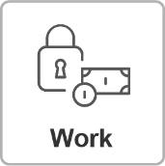 | More and more workplaces and business processes are being digitalised, whereas electronic signatures and seals enable paperless and legally compliant workflows.
 | Digital processes in the realty sector often require an especially high level of trust, which can be provided by eID and trust services according to the eIDAS-Regulation.
 | The education sector is reinventing itself in the digital era, whereas eID, electronic signatures and seals serve as promoter of trustworthy digitalisation of educational and administrative processes. ERASMUS+ is a prominent example.
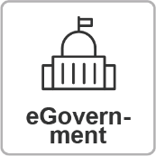 | Digital government processes have a huge potential to increase efficiency and trust for authorities and enterprises as well as transparency and convenience for citizen. eID, electronic signatures, seals and related trust services play a key role in trustworthy eGovernment processes.
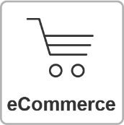 | eID and trust services have the potential to improve security and trust in electronic commerce. The use of secure digital identities, qualified website authentication certificates (QWACs) and other trust services creates mutual trust – especially in cross-border transactions.
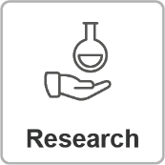 | eIDAS means allow to improve trust, efficiency, integrity and authenticity in research processes in the food and drugs industry for example. Secure cloud service frameworks using eID and trust services for secure access management could protect sensitive research results.
 | Digitisation is revolutionising the entire healthcare sector, which has specific requirements with respect to security, privacy and trust. eID and trust services enable secure medical records, the trustworthy data exchange between smart devices and critical infrastructures, personalised pharmacotherapy and other innovative digital processes within the healthcare sector.
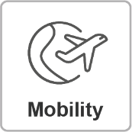 | The omnipresence of smartphones with NFC is pushing forward the digitalisation of passenger transport processes, whereas eID and electronic signatures in smartphone apps enable trustworthy ticketing. This offers new possibilities for information transfer, networking and the smart organisation of traffic and travel.
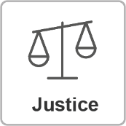 | Qualified electronic signatures and related eIDAS services play an important role within electronic business processes in the Justice domain to foster trust and transparency for all stakeholders while maintaining legal compliance.
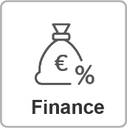 | The financial sector is one of the largest beneficiaries of eID and trust services. Due to pertinent regulations related to payment or anti-money laundering, there is a significant demand for eIDAS services, which foster digitalisation, trust and efficiency in this domain.
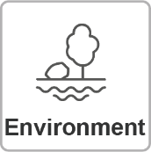 | Smart electronic technologies based on secure digital identities and trust services may help to sustainably protect our environment due to smarter workflows and the trustworthy sharing of data. For example, “smart home” concepts may not only save money, but also help to protect the environment.
 | The industrial sector is about to reinvent itself using a variety of digital technologies. A challenge for today’s manufacturing industry is how fast the Industrial Internet of Things (IIoT) is changing the competitive landscape. The eIDAS framework allows to boost efficiency, while ensuring trust and compliance of digital services in this sector.
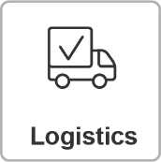 | Smart digital technologies and paperless yet traceable business processes provide the basis for improving the efficiency and trust in the logistics sector. eID and trust services according to the eIDAS-Regulation enable seamless and efficient business processes and binding transactions within Europe and beyond.

About the go.eIDAS-Association

The go.eIDAS-Association has been initiated by leading European associations, projects and expert organisations in the sector of eID and trust and aims at supporting the practical implementation of the eIDAS-Regulation (EU) 2014/910 on electronic identification and trust services for electronic transactions in the internal market in order to create an open, inclusive, secure, privacy-friendly and trustworthy eIDAS-Ecosystem. The go.eIDAS-Association welcomes all interested organisations and individual persons which want to benefit from and push forward the adoption of eIDAS in Europe and beyond.

Please refer to https://go.eID.AS for further information and latest news with respect to go.eIDAS.

Contact:

Tina Hühnlein
go.eIDAS-Association (go.eIDAS e.V.)
Judengasse 2, 96215 Lichtenfels
Germany
https://go.eID.AS
go@eID.AS
@go_eIDAS
https://www.linkedin.com/groups/8807996

See https://blog.eid.as/eidas-ecosystem/ for more information on eID-Services, Certification Authorities (CA), Time Stamping Authorities (TSA), Signature Generation & Sealing Services (SigS), Validation Services (ValS), Preservation Services (PresS) and Electronic Delivery Services (EDS) according to the eIDAS-Regulation.

